Rida Zakiyah ^{a,1}, Julison Arifin ^{b,2}, Endang Sugiharti^{c,3},
Masjraul Hidayat^{d,4}, Heri Subagyo^{e,5}
^{1,3,4,5} Trisakti Insitute of Transportation and Logistics, Jakarta, Indonesia
²Sumatera Institute of Technology, Lampung, Indonesia

^{1*} zakiyah.rida@yahoo.co.id, ²joylisann@gmail.com, ³artisuli96@gmail.com
⁴rulihid@gmail.com, ⁵hsubagyo88@yahoo.cu.uk

Corresponding e-mail: zakiyah.rida@yahoo.co.id

Analysis of Underpass Development on The Train Cross,
South Tambun, Bekasi, Indonesia

This is an open access article under the terms of the CC-BY-NC license

ABSTRACT

This study aims to improve safety and security for vehicle users passing through the tunnel, identify the construction of underpasses at railroad crossings, minimize queue lengths and delays while crossing on Jalan Sultan Hasanudin, Pasar Tambun, Bekasi and improve road smoothness, and provide recommendations for the need for pedestrian facilities on the Jalan Sultan Hasanudin section. There is a potential safety risk for pedestrians, because there are no pedestrian crossing facilities. Then analyze the benefits of underpass construction on level crossings for road users. The method used is descriptive quantitative analysis, namely in the form of calculating traffic performance, technical requirements of the railway line, the benefits of the underpass for train operations and the need for pedestrian crossing facilities. The results of the analysis identify the need for underpass maintenance costs for safety and security for passing vehicle users. It is necessary to add a zebra cross and pelican on Jalan Sultan Hasanudin on pedestrian facilities to cross, close the u-turn of the Ataqwa mosque which is moved to the u-turn access of the police station, south Tambun, then the construction of the tunnel is very useful for rail operations and road users.

Keywords: Traffic Engineering, Underpass, Pedestrian, U-Turn, The Train

- Introduction
Level crossings or intersections and/or intersections between railway lines and other buildings are accident-prone points that are difficult to resolve given the low discipline of road users to comply with warning signs at level crossings (Aswad, 2013). Accident data from 2015 to 7 June 2019 accidents at level crossings were 1,470 incidents with details of 179 incidents at guarded level crossings and 1,291 at unguarded crossings, this shows the lack of awareness of road users to prioritize train travel. Pada perlintasan sebidang antara jalur kereta api dengan jalan pengemudi kendaraan wajib berhenti ketika sinyal sudah berbunyi, palang pintu kereta api sudah mulai ditutup dan/atau ada isyarat lain untuk mendahulukan perjalanan kereta api (UU RI, 2009).
Underpass is a road that is below ground level (Santosa et al., 2016), the main part of which is a road, rail, or pedestrian path. The underpass is an alternative to be able to overcome the long queue of vehicles at the intersection, the function of using the underpass is to improve the road geometry, to be able to provide comfort and safety for pedestrians and road users. In RTRW (Rencana Tata Ruang Wilayah) of Bekasi Regency, Tambun Selatan District as the urban center is part of the Jabodetabek PKN urban system which carries out the function of national-scale industrial development. Based on data from the Central Statistics Agency in 2018, the population of South Tambun District in Bekasi Regency is 134,067 people with an area of 4,310 Ha. Long queues and delays on roads are common problems in Bekasi Regency, especially at the Pasar Tambun intersection.
At the Pasar Tambun Intersection there is a Mekarsari Street section in the north which is a residential area and there is a Tambun Station, the west is Jalan Sultan Hasanudin I which is the Tambun market area and access to Bekasi City, then the east is Jalan Sultan Hasanudin II access to Cikarang which there is an industrial area. In the area there are long queues and delays due to the disproportionate volume of vehicles and road volume. Based on the results of the survey the performance of the existing intersection produces a delay at busy time of 14 seconds with service level B, but the service level of Jalan Sultan Hasanudin D is unstable vehicle volume with high-passing vehicles with the lowest speed of 50 km/hour. The level of service on arterial roads is at least C (PM RI, 2015).
There are no road crossing facilities, in this case there is a potential risk to pedestrian safety, pedestrians are part of the traffic movement because their activities are moving. To ensure the safety of pedestrians, their rights and obligations in traffic are regulated, and they are entitled to the availability of supporting facilities.
The underground crossing with a length of 162 meters was inaugurated on 10 May 2017, in this case there is no underpass maintenance. Tunnel maintenance started 5 years after the tunnel operation. Then it is necessary to calculate the maintenance cost for the underpass (Firmansyah & Istiar, 2016; Muzdar et al., 2018. Based on data, the number of daily train trips in the Tambun area is 49 commuterline (source: KRL Access, 2021) and 18 long-distance trains (source: KAI Access, 2021) with an average number of accidents of 1 accident per day. There is no benefit of underpass construction on Jalan Mekarsari for road users. Analyzing the construction of underpasses at railroad crossings. To overcome the problems that occur at the Pasar Tambun intersection, this study will examine the feasibility of constructing an underpass at the railroad crossing at Pasar Tambun intersection. Congestion at level crossings is due to the closing of the crossing gates to prioritize train travel, resulting in a queue of motorized vehicles (Hartono, 2016).

- METHODS
The research method used is quantitative descriptive analysis in the form of calculating traffic performance, technical requirements of the railway line, the benefits of the underpass to road users, the cost of maintaining the underpass and the need for pedestrian crossing facilities. The research stages start from identification of existing problems, secondary data collection, primary data collection, traffic analysis of existing conditions, traffic analysis of plan conditions, model validation, followed by conclusions and suggestions.
This research used primary and secondary data, primary data were obtained from survey at the intersection of the Pasar Tambun. The survey carried out was an inventory of roads and intersections with the target data in the form of images of the geometric conditions of the intersection as well as facilities and equipment along with a cross section, the classified turning movement counting survey conducted direct observations and enumerations at each leg of the intersection within a certain period of time, and a survey of past travel speed. traffic on a road segment by noting the length of time the obstacle, the location and the causes of the obstacle. Secondary data were obtained from government in Bekasi Regency. It was also obtained from various texts such as books, journals, and related articles as a literature review to analyze more deeply. Testing the inter-relationship between variables using chi-square test, and then compiled a recapitulation of the results of the bivariate analysis and will be known whether the five variables of the research are interconnected.

- Results and Diccussion
- Underpass Maintenance
Regulation of the Minister of Public Works and Public Housing Number 13 PRT of 2011 concerning Procedures for Road Maintenance and Surveillance (PM RI, 2011). Development costs have increased every year due to inflation. The amount of inflation that occurred based on the inflation rate of Bank Indonesia was 4.82%. So, the tunnel maintenance cost in 2022 is Rp. 9,590,327,674.00.
- Benefits of the Underpass on the Road
Underpass needs to be done because it is very useful for the smooth running of road users (Sudarmanto, 2018). In addition, every train that crosses the level crossing, requires a waiting time of 3 minutes for road users. Starting from the safety time before the train passes (the clapper signal for the train that will pass) + the release time (opening) of the JPL doorstop. In a day the benefits of underpass construction for road users are at least 360 minutes or the equivalent of 6 hours per day. In one day, the benefit of underpass construction for road users are at least 360 minutes or equivalent to 6 hours for each day.

- Railroad Free Space
The railroad free space in the tunnel takes into account the type of rail facilities operated and the ballasted or unballasted system. The dimensions of the tunnel are determined by the free space plus at least 100 mm for maintenance.
The railroad free space of track complies with the standard provisions of PM Number 60 Year 2012 About Railroad Technical Requirements (PM RI, 2012), the following is an image free space on the rail road (Figure 1).

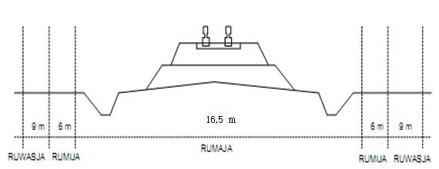
Figure 1 Free Space on Railroads

The free space on the rail road complies with the standard provisions, namely:
- Railroad Benefit Space at least 2.75 meters from the axle
For the benefit space of the railway line, it has met the standard provisions of 2.75 meters.
- Space Owned by Railroad 6 meters
The space belonging to the railroad has met the 6 meter standard. The space belonging to the railway line is intended to secure the construction of the rail road.
- Ruang Pengawasan Jalur Kereta Api (tidak ada batas minimum)
A piece of land outside the road belonging to the road that must be monitored, so that all activities and development within the boundaries of the ruwasja do not interfere with train operations. The field on the rumija has a function to secure and expedite the train.

- Pedestrian Facilities
From the results of the pedestrian survey, it was found that the volume of pedestrians crossing, then obtained reference data in determining crossing facilities (Junaedi, 2014). Then the recommendations for crossing facilities will be obtained by looking at the number of people crossing and the volume of vehicles. The following is the result of determining the crossing facilities (Table 1).

Table 1 Calculation of Recommendation for Selection of Types of Crossings for Pedestrian Facilities
Time  60 Minutes | Pedestrian Crossing (P) | Vehicle (V) | V² | PV²
07:00-08:00 | 83 | 1375 | 1890625 | 156921875
08:00-09:00 | 69 | 1324 | 1752976 | 120955344
12:00-13:00 | 66 | 1497 | 2241009 | 147906594
13:00-14:00 | 46 | 1285 | 1651225 | 75956350
15:00-16:00 | 55 | 1451 | 2105401 | 115797055
16:00-17:00 | 48 | 1526 | 2328676 | 111776448
Average |  |  |  | 121.552.277,67

From the results of the calculations above, it is obtained recommendations for different crossing facilities, namely the zebra cross and pelican recommendations. This is influenced by the number of pedestrians and the average number of vehicles which are in the range of 50 – 1100 (PU RI, 1997). Then for the recommended image of crossing facilities (Figure 2).
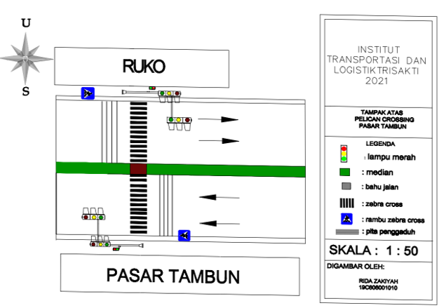
Figure 2 Top View of Pelican Crossing Pasar Tambun

In planning the duration of the pelican crossing lights, it is calculated only in period 4 as shown in the table below, while for period 1 the standard time is 7 seconds (Transport, 1995).
PT = $\frac{12}{1,2}+$1,7 $(\frac{83/60}{2,5-1})$ = 11,57 = 12 seconds

Table 2 The Period of the Pasar Tambun Pelican Crossing Lights
Period | Traffic Lights |  | Duration  (Seconds)
Period | Vehicle | Pedestrian | Duration  (Seconds)
1 | Green | Red | 7
2 | Yellow | Red | 3
3 | Red | Red | 3
4 | Red | Green | 12
5 | Red | Flashing Green | 3
6 | Red | Red | 3

- Closing of U-Turn Access
One of the effects when making a reverse motion is the speed of the vehicle where the vehicle will slow down or stop. This slowdown will affect the flow of traffic in the same direction (Maer et al., 2019). In certain vehicles, to make a U-turn motion, it is not possible to directly make a rotation due to the condition of the vehicle that does not have a sufficient turning radius, so that it will cause other vehicles to be disturbed and even stop either from the same direction or from the opposite direction to be traversed (Balaka & Djalante, 2017). Jalan Sultan Hasanudin in Bekaasi Regency, West Java Province, is an arterial road with a relatively high traffic volume and there is a median opening (U-turn).
Based on observations at the study site, it is seen that there are vehicles that cannot perform U-turn movements smoothly, wherein the vehicle must perform additional maneuvers in order to fully adjust the turning movement. These conditions can cause security problems and U-turn and straight vehicles. Here is recommendations for Closing the Pasar Tambun Intersection (Figure 3):
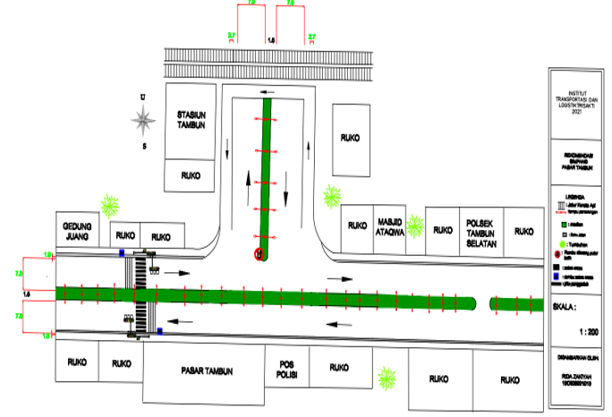
Figure 3 Recommendations for Closing the Pasar Tambun Intersection

On this road, congestion often occurs due to the flow being too high, and is influenced by several activities of shops, offices and markets located in the location of the road segment (Figure 3). With traffic flow and high side barriers activities that can hinder economic development and development, in this case it is necessary to close the U-turn so that it is useful to be able to facilitate the flow of traffic in the area (Tamin, 2003). Vehicle users who want to make a U-turn can do a U-turn at the Tambun Selatan Police, which is 290 meters from the foot of the intersection or 110 meters from the U-turn access that will be closed.

- Conclusion
Maintenance of periodic underpass construction started in the 5th year since it was operated in 2017. The cost of maintenance costs in 2022 is Rp. 9,590,327,674.00. In this case, development has increased every year due to the inflation that occurs, the magnitude of the inflation rate that occurs is based on the inflation rate of Bank Indonesia of 4.82%.
The recommendation for pedestrian crossing facilities with zebra cross and pelican crossing with a cycle time of 31 seconds and a pedestrian duration of 12 seconds, this is influenced by the number of pedestrians on Jalan Sultan Hasanudin and the number of vehicles in ${<10}^{8}$ for provision crossing facility.
Closing the U-turn access on Jalan Sultan Hasanudin, can eliminate the 25 second delay caused by the vehicle making a U-turn. Then the vehicle can make a U-turn at the Tambun Selatan Police Station, 290 meters from the foot of the intersection.
In the free space the rail road has complied with the standard provisions, are; The Railroad Benefit Space of 16.5 m has complied with the minimum standard of 2.75 m from the axle, the Railway Owned Space is 6 m and the Railway Track Control Room is 9 m. The number of daily train trips in the Tambun area is 49 commuterline and 18 long-distance trains with an average number of accidents of 1 accident per day. Based on the facts, that is because the crossing gate is in a damaged or malfunctioning condition and there is no free space for drivers to see the arrival of the train that will pass.
There are benefits to the construction of the underpass, namely the waiting time of 3 minutes for each train or 6 hours a day for trains crossing level crossings for road users.

- References
Aswad, Y. (2013). Studi Kelayakan Perlintasan Sebidang antara Jalan Kereta Api dengan Jalan Raya. Media Komunikasi Teknik Sipil, 19(2), 183-189. https://doi.org/10.14710/mkts.v19i2.8430
Balaka, R., & Djalante, S. (2017). Kajian Perbandingan U-Turn (Putar Balik Arah) Pada Jalan Menerus Dan Jalan Simpang (Studi Kasus: Jalan Kapt. P. Tendean Depan RS. Bahteramas Dan Simpang Tiga Pasar Baruga). STABILITA|| Jurnal Ilmiah Teknik Sipil, 5(3), 18-26.
Firmansyah, N., & Istiar, I. (2016). Studi Kelayakan Pembangunan Fly Over di Simpang Gedangan Sidoarjo Ditinjau dari Segi Lalu Lintas dan Ekonomi Jalan Raya. Jurnal Teknik ITS, 5(2), E66-E70. https://doi.org/10.12962/j23373539.v5i2.18895
Hartono, H. (2016). Perlintasan Sebidang Kereta Api di Kota Cirebon. Jurnal Penelitian Transportasi Darat, 18(1), 45–62. https://doi.org/10.25104/jptd.v18i1.110
Junaedi, T. (2014). Analisis Keselamatan Pejalan Kaki Pada Simpang Bersinyal. Jurnal Rekayasa Teknik Sipil Universitas Lampung, 18(3), 140649.
Maer, J., Lefrandt, L. I., & Timboeleng, J. A. (2019). Analisis pengaruh U-Turn terhadap karakteristik arus lalu lintas di ruas Jalan Robert Wolter Monginsidi Kota Manado. Jurnal Sipil Statik, 7(12), 1569–1584.
Muzdar, M. A., Heryanto, B., & Akil, A. (2018). Fenomena Spasial Pada Fly-Over Urip Sumoharjo KM. 4 Makassar. Nature: National Academic. Nature: National Academic Journal of Architecture, 5(2), 105-114. https://doi.org/10.24252/nature.v5i2a3
Novenanto, A. (2018). Transjawa, Pertumbuhan Ekonomi, dan Urbanisasi. BHUMI: Jurnal Agraria Dan Pertanahan, 4(2), 123-139. https://doi.org/10.31292/jb.v4i2.275
PM RI. (2011). Regulation of The Minister of Transportasion of The Republic of Indonesia PM Number 13 PRT Year 2011 About Road Maintenance and Surveillance Procedures.
PM RI. (2012). Regulation of The Minister of Transportasion of The Republic of Indonesia PM Number 60 Year 2012 About Railroad Technical Requirements.
PM RI. (2015). Regulation of The Minister of Transportasion of The Republic of Indonesia PM Number 95 Year 2015 About Guidelines for the Implementation of Traffic Management and Engineering Activities.
PU RI. (1997). Indonesian Road Capacity Manual.
Santosa, L. S., Suthanaya, P., & Adnyana, I. (2016). Studi Kelayakan Ekonomi Pembangunan Underpass Pada Simpang Jl. Gatot Subroto-Jl. Ahmad Yani Di Kota Denpasar. Jurnal Spektran, 59-68.
Sudarmanto, B. (2018). Kajian Kebutuhan Perlintasan Tidak Sebidang Jalur Kereta Api Dengan Jalan Raya di Titik Perlintasan Ganefo Kecamatan Mranggen. Teknika, 13(2), 65-71. https://doi.org/10.26623/teknika.v13i2.1303
Tamin, O. Z. (2003). Perencanaan dan Pemodelan Transportasi (2nd eds). Bandung: ITB.
Transport, U. D. of. (1995). The Design of Pedestrian Crossings. Local Transport Note LTN-1/95. London, United Kingdom: Department of Transport.
UU RI. (2009). Law of the Republic of Indonesia Number 22 of 2009 concerning Road Traffic and Transportation.

